3.1.1. Largest of Three Numbers
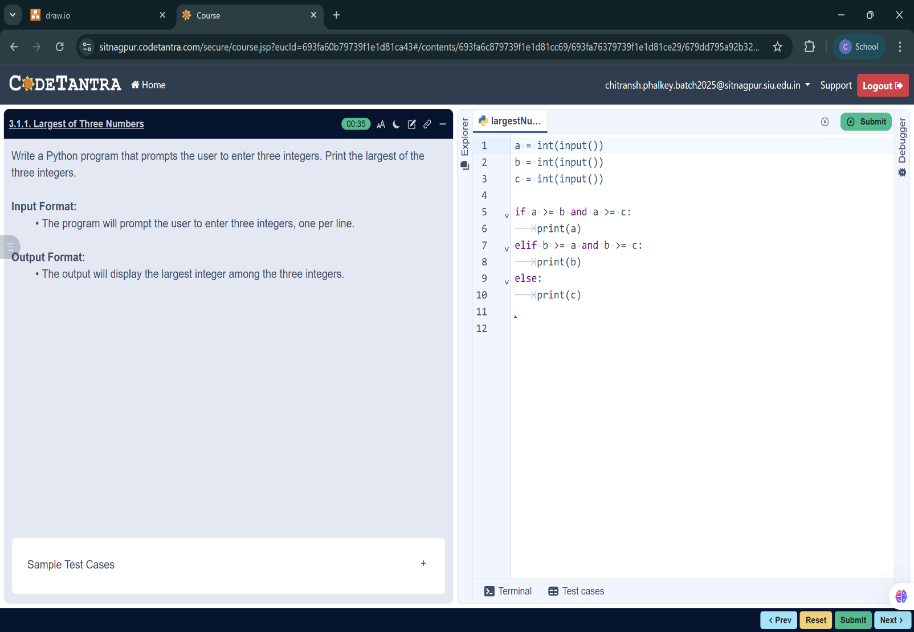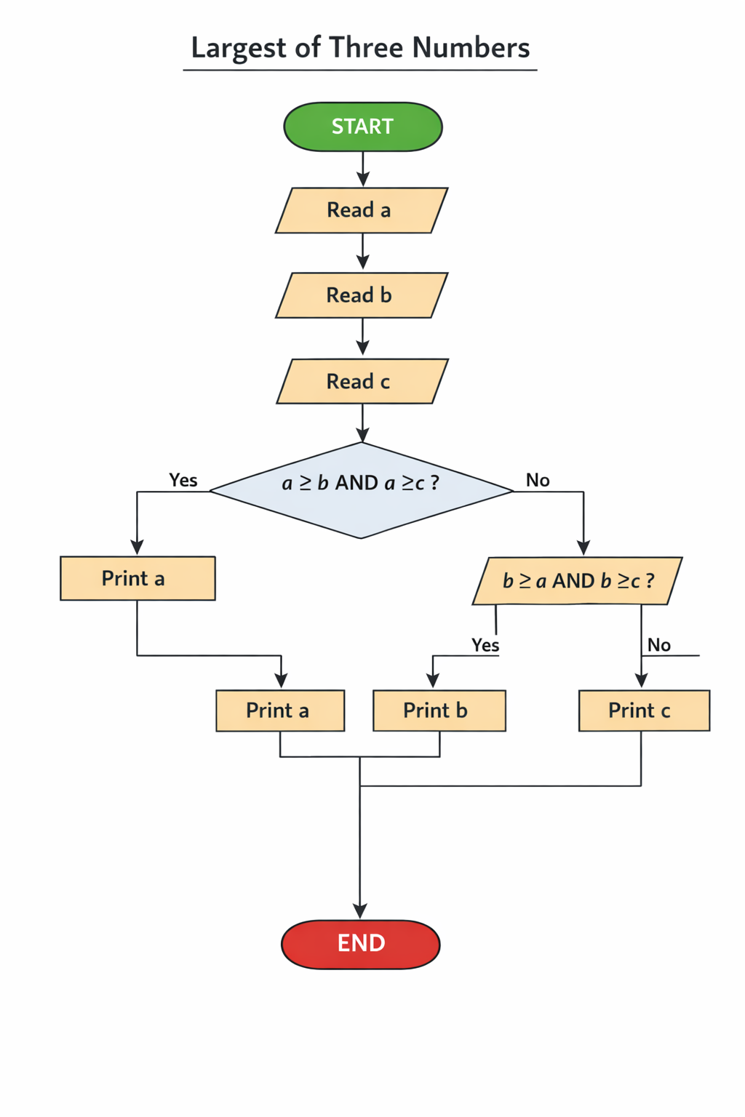

ALGORITHM: TO FIND THE LARGEST OF THREE NUMBERS
Step 1: Start
Step 2: Read the value of a
Step 3: Read the value of b
Step 4: Read the value of c
Step 5: If a ≥ b AND a ≥ c, then
Print a
Step 6: Else if b ≥ a AND b ≥ c, then
Print b
Step 7: Else
Print c
Step 8: End

